JSS 2 3RD TERM BST CHEMISTRY NOTE.
SCHEME OF WORK
WEEK | TOPIC | CONTENTS
1 | DISPLACEMENT REACTION | -Displacement reactions  -Electrochemical series
2 | RATES OF CHEMICAL REACTIONS | -Definition of terms  -Factors affecting the rate of chemical reactions
3 | RATES OF CHEMICAL REACTIONS | -Factors affecting the rate of chemical reactions
4 | EXOTHERMIC AND ENDOTHERMIC PROCESS | -Exothermic and endothermic process  -energy profile diagram
5 | CARBON | -Allotropy  -Allotropes of carbon
6 | CARBON | -Allotropes of carbon; properties, uses as related to their properties
7 | HYDROCARBONS | -Source  -Classification
8 | INTRODUCTION TO ORGANIC CHEMISTRY | -Tetravalency of carbon  -Reason why carbon forms a lot of compounds  -Catenation
9 | INTRODUCTION TO ORGANIC CHEMISTRY | -Homologous series  -Characteristics  -Examples
10 | REVISION
11 | EXAMINATION

WEEK1
DISPLACEMENT REACTION.
A displacement reaction is a type of chemical reaction in which one element displaces another element from its compounds. The ability of an element to displace another is dependent on the position of the elements on the electrochemical series. Both metals and non-metals take part in displacement reactions. Example 1. Zinc is more reactive than copper (higher than copper in the electrochemical series), when zinc is reacted with a copper compound, the copper is displaced.
Zn_{(s)} + CuSO_{4 (aq)} ZnSO4_{(aq)} + Cu_{(s)}
Mg_{(s)}+CuSO4_{​(aq)}⟶MgSO4_{​(aq)}+Cu_{(s)}
Example 2. Fluorine is higher than bromine in the activity series of nonmetals and can displace it from its compound.
F₂ + 2HBr 2HF + Br₂
THE ELECTROCHEMICAL SERIES
This is a table which places elements in the order of reactivity. This is also known as the activity series. It has for both metals and nonmetals.
ACTIVITY SERIES OF METALS
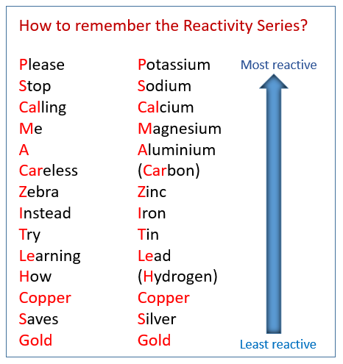
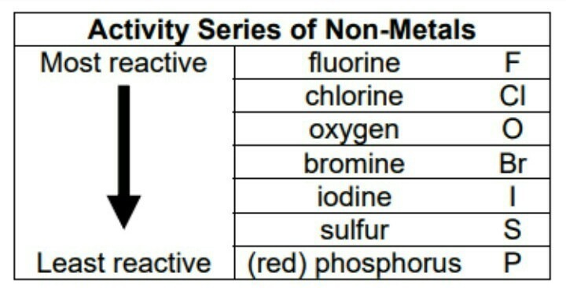
WEEK 2-3
RATE OF CHEMICAL REACTION
The rate of a chemical reaction is the number of moles of reactants converted or product formed per unit time
Calculating reaction rate
Most methods for determining reaction rates involve a change in the concentration of one of the components of the reaction with time
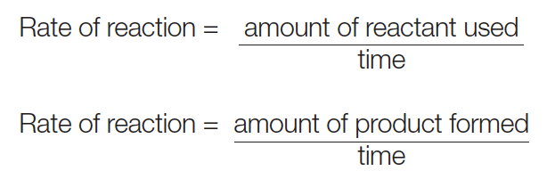
Example
0.2g of magnesium ribbon reacts completely with dilute hydrochloric acid in 40 seconds. What is the rate of reaction
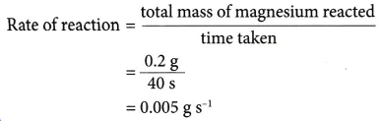
The Collision theory
This theory is used to predict the rates of chemical reactions, particularly for gases. The collision theory is based on the assumption that for a reaction to occur it is necessary for the reacting species (atoms or molecules) to come together or collide with one another.
According to the collision theory;
- Molecules must collide in order to react.
- In order to effectively initiate a reaction, the colliding particle must posses a certain minimum amount of energy called activation energy
- As the temperature rises, molecules move faster and collide more vigorously, greatly increasing the likelihood of bond breakage upon collision.
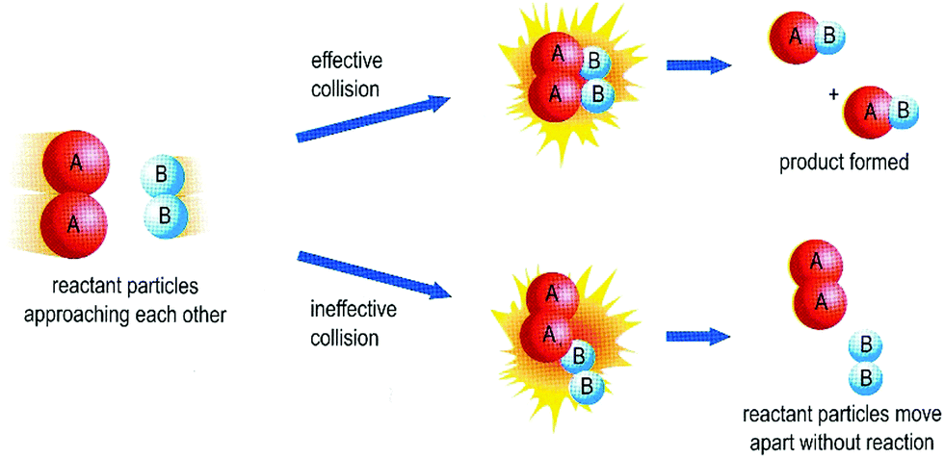
Factors that affect the rate of chemical reactions
- Temperature of reaction mixture
- Concentration of reactants
- Pressure of gases
- Surface area of reactants
- Presence of Catalysts
- Nature of reactants
- Presence of light

Temperature of reaction mixture
An increase in temperature typically increases the rate of reaction. An increase in temperature will raise the average kinetic energy of the reactant molecules. Therefore, a greater proportion of molecules will have the minimum energy necessary for an effective collision
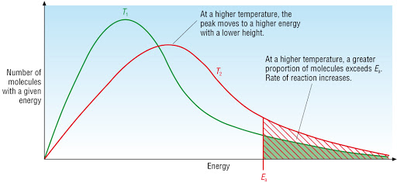
Concentration of reactants
Increasing the concentration of one or more reactants will often increase the rate of reaction. This occurs because a higher concentration of a reactant will lead to more collisions of that reactant in a specific time period.
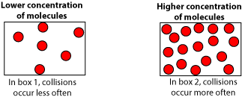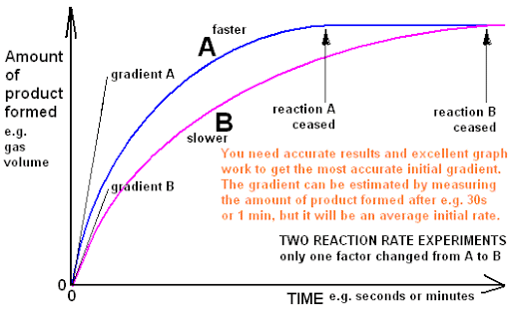
Pressure of gases
increasing the pressure of a gas is exactly the same as increasing its concentration. If you have a given mass of gas, the way you increase its pressure is to squeeze it into a smaller volume. If you have the same mass in a smaller volume, then its concentration is higher.
Increasing the pressure on a reaction involving reacting gases increases the rate of reaction. Changing the pressure on a reaction which involves only solids or liquids has no effect on the rate.
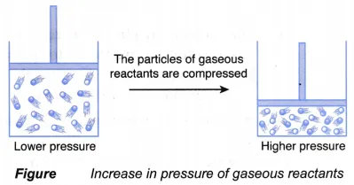
Surface area of reactants
To increase surface area of a solid means to grind it into smaller pieces. An increased surface area leads to an increased rate of reaction.
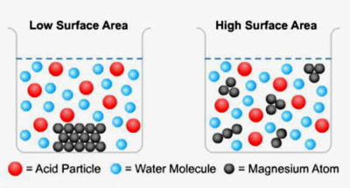
Presence of a catalyst
A catalyst is a substance that accelerates a reaction by participating in it without being consumed. Catalysts provide an alternate reaction pathway to obtain products. It increases the reaction rate by lowering the activation energy for a reaction.
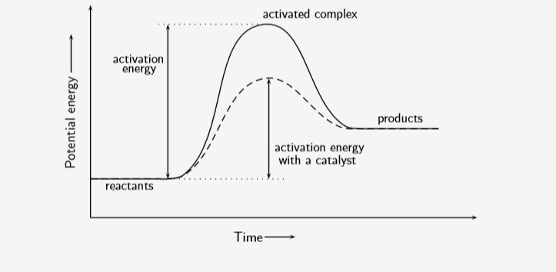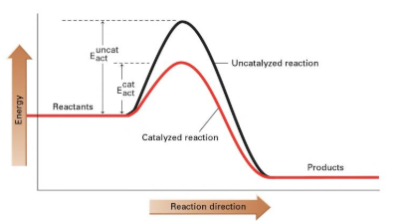
Nature of reactants
When a piece of iron is placed in dilute hydrochloric acid, there is a slow evolution of hydrogen gas. With a piece of zinc, hydrogen is evolved rapidly and with a piece of Gold, there is no evidence of a reaction.
Thus, the rate of a chemical reaction is determined by the chemical nature of the reactants as different suzbstances have different energy contents
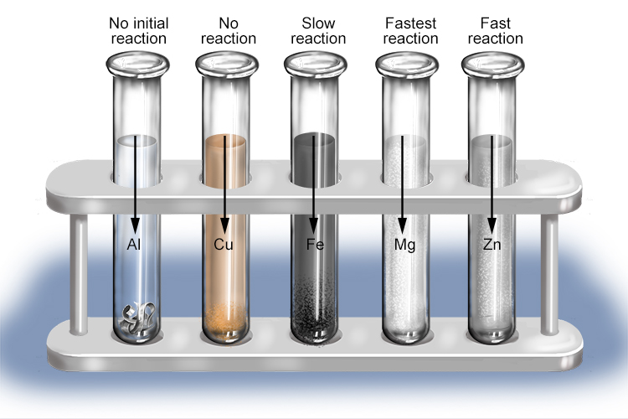
Presence of Light
Some reactions are influenced by light. The greater the intensity of light (visible or ultra-violet) the more reactant molecules are likely to gain the required energy (activation energy) and react, so the reaction speed increases - greater frequency of initiation.
Examples of photochemical reactions include
- Reaction of hydrogen and chlorine
- Decomposition of hydrogen peroxide
- Reaction of methane with chlorine
- Photosynthesis
- Conversion of silver halides to gray metallic silver (used in Photography)
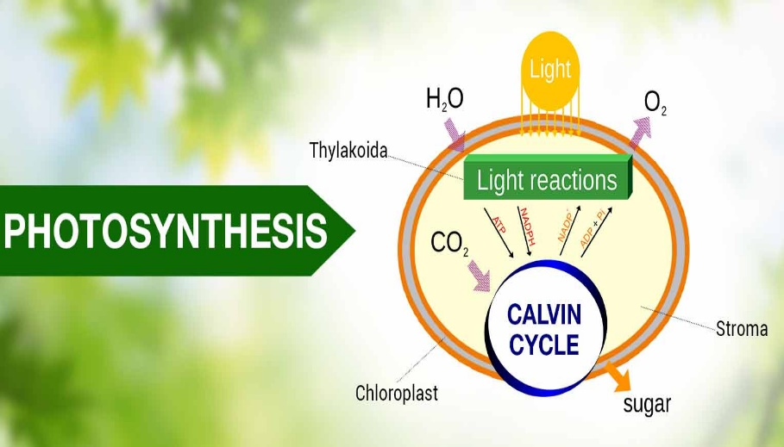
WEEK 4
EXOTHERMIC AND ENDOTHERMIC PROCESSES
Exothermic Reaction: this a chemical process in which is released to the surroundings. In this type of reaction, the heat energy of the product is less than that of the reactant.
ENERGY PROFILE DIAGRAM OF EXOTHERMIC REACTION
Endothermic reaction: this a chemical process in which heat is absorbed from the surrounding. In this type of reaction, the heat energy of the product is greater than that of the reactant.
ENERGY PROFILE DIAGRAM OF ENDOTHERMIC REACTION

Allotropy
This is the ability of an element to exist in various forms in the same physical state. Elements that exhibit allotropy include carbon, sulphur, tin, oxygen, phosphorus etc
Allotropes of Carbon
- Crystalline allotropes: diamond and graphite
- Amorphous allotropes: coal, coke, charcoal, soot etc
Structure of diamond and graphite
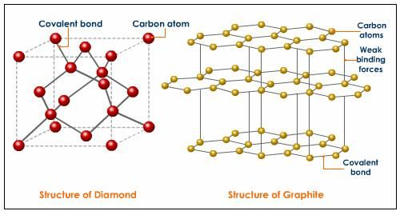
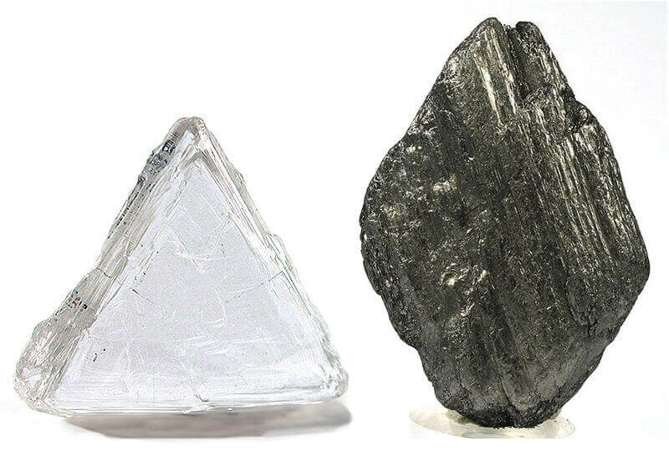

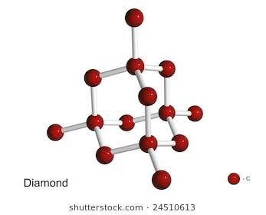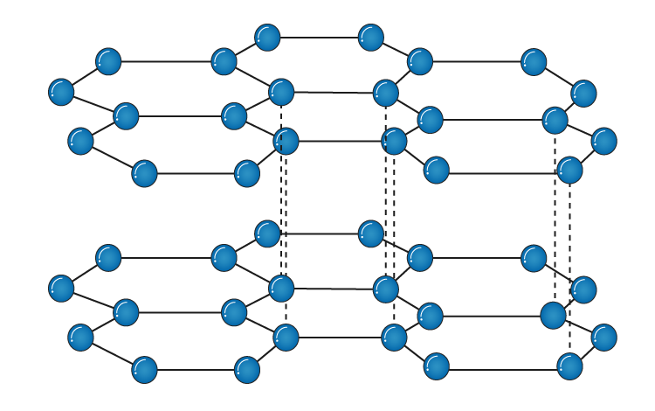
Properties and uses of diamond
- Diamond is the hardest substance known in nature. They are dense, hard and resistant to high temperatures and chemical attacks;
i. They are used industrially in drills for mining,
ii. as abrasives to sharpen very hard tools and for cutting glass and metals.
- it is a non-conductor of electricity due to the absence of free mobile electrons
- they are transparent with high refractive index and dispersion power giving it a sparkling brilliance when it is cut and polished;
i. making it valuable as jewellery.
- It occurs as octahedral crystals
Properties and uses of Graphite
- Graphite is soft and flakes easily because of its layered crystalline structure held together by van der waals forces. This allows one layer to slide over one another easily;
i. making it useful as a dry lubricant,
ii. it is mixed with clay to make lead in pencils,
iii. it is usually used on bicycle chains and for the bearings of some motor cars.
- Graphite is a good conductor of electricity due to the presence of free mobile electrons
i. it is often used as electrodes in electroplating and in dry cells
- It can with stand high temperatures
i. it is used to line crucibles used for making high grade steel and other alloys.
ii. It is used as a neutron moderator in atomic piles
- It is black and opaque
i. graphite is used as black pigment in paint.
- It occurs as hexagonal crystals

