Introduction to Bookkeeping
Specific objectives: By the end of this lesson, I should be able to:
- Define bookkeeping
- List the 6 types of transactions
- Define account
Bookkeeping is the process of recording all financial transactions made by a business. The person who keeps these records is known as a Bookkeeper.
Double Entry Book-keeping
Every financial transaction in a business has two effects: one account gives a benefit and the other account receives a similar benefit. Double entry book-keeping means that the bookkeeper must record both the ‘giving’ and the ‘receiving’ in the 2 accounts as a debit or a credit.
Financial transactions in a business can be classified into 6 types:
(remember it using D. E. A. L. E. R)
- Drawings: this is a record of the money value taken from the business by the owner of the business for his/her personal use.

- Expenses: these are costs that have been totally used up in the process of generating revenue. Examples of expenses are Purchases; Salaries/Wages; Rent; Insurance; Maintenance and repairs etc.

- Assets: this is any resource that is controlled by the business and can be used to generate revenue in the future. Examples of assets are Cash; Debtors; Land and buildings; Equipment; Furniture and Fittings; Prepayments; Inventory etc.

- Liabilities: this is the money that the business now owes to others because of the benefits that it received in the past. Examples of liabilities are Creditors; Salaries/Wages Payable; Interest Payable etc.

- Equity: this is the difference between the assets and liabilities of a business. Examples are Owner’s capital; Dividends etc.

- Revenue: this is the money received by the business because it sold a good. Examples are Sales revenue; Income; Gain on disposal of assets; etc.

A bookkeeper records transactions by creating an Account. An account can be defined as a written record of the financial benefits that were given or received by any part of the business.

THE LEDGER
Specific objectives: By the end of this lesson, I should be able to:
- Define ledger
- List 4 types of ledger books
- Explain the 2 types of ledger accounts
- Draw the format of a ledger

The Ledger is a book of final entry containing accounts in which business transactions are recorded in the form of debits and credits. The accounts are called ledger accounts.
The transfer of entries from journal to ledger is known as Posting.
The Format of a Ledger is shown below
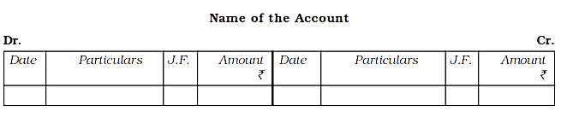
A transaction is DEBITED (Dr.) if it causes a Drawing, Expense or Asset to increase.
A transaction is CREDITED (Cr.) if it causes a Liability, Equity or Revenue to increase.

Types of Ledger Books
- Sales Ledger: This contains a separate account for each individual to whom goods have been sold, or for whom services have been performed on credit. It is also called Debtor’s Ledger.

- Purchases Ledger: This contains the personal accounts of those who have supplied goods or rendered services to the business on credit. It is also called Creditor’s Ledger.

- General Ledger: It is a ledger in which real and nominal accounts are kept.

- Private Ledger: This is a confidential ledger kept by either the proprietor (owner of business) or the Accountant outside the reach of the other staff.

Types of Ledger Accounts: There are 2 types of Ledger accounts
1. Personal Accounts: These are accounts in which transactions with individuals or other organizations are entered. Examples of personal accounts are debtors and creditors accounts.
2. Impersonal Accounts: This is sub-divided into Real accounts and Nominal accounts
(i) Real Accounts: These accounts contain records of transactions of things you can see physically. Examples are motor vehicle accounts, furniture account, buildings account, machinery account etc.
(ii) Nominal Accounts: These deal with things that cannot be touched like revenue, expenses, salaries etc.

THE CASH BOOK
Specific objectives: By the end of this lesson, I should be able to
- Define a cash book
- List the 3 types of cash book
- Differentiate between the trade discount and cash discount
- Explain a contra entry

A Cash Book records only the cash transactions of an organization. The cash of a business is made up of cash in hand and cash in the bank. The cash book is both a journal and a ledger.
There are 3 types of cash book
- Simple cash book
- Two-column cash book
- Three-column cash book

- Simple Cash Book: this type of cash book is used to record only cash in hand which is paid or received by the business.
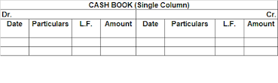
- Two-column cash book: this type of cash book records both the cash-in-hand and cash in bank eg transfers, cheques and P.O.S operations

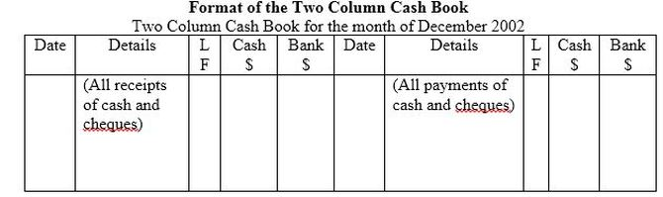

- Three-column cash book: this type of cash book records cash in hand, bank transactions and discounts received and discount allowed by the business.
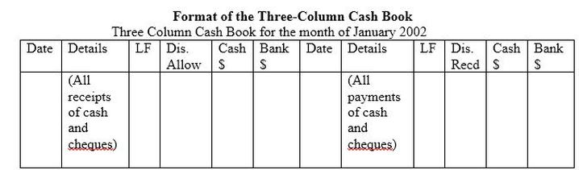

2 Types of Discount
1. Cash Discount: The term cash discount refers to the reduction of the total amount to be paid. It is given to encourage quick payment. The cash discount can be discount allowed or discount received.
(i) Discount allowed: A reduction given to debtors who pay their accounts within the time limit. Discount allowed is an expense for the business.
(ii) Discount received: A reduction given to the business by its creditors when we pay their accounts before the time allowed has elapsed. Discount received is an income for the business.
2. Trade Discount: Trade discount is the reduction allowed from the list price (selling price) of the goods.
Note: Only cash discounts are recorded in the cash book.

Contra-Entry
A contra-entry is any transactions involving a transfer of cash between cash accounts and bank accounts. It is represented by letter ‘C’ in the folio column. The following is the list of contra entries:
- Cash account to Bank account
- Bank account to Cash account
- Bank account to Bank account
- Cash account to Petty Cash account
THE PETTY CASH BOOK

Specific objectives: By the end of this lesson, I should be able to
- Define petty cash book
- Draw the analytical format of a petty cash book
- Explain the imprest system
- List 4 advantages of the imprest system

A petty cash book is a cash book used for recording small or minor expenses of the business. Examples of minor expenses are dispatch costs, carriage, stationery, light refreshments etc.
To establish the petty cash an amount called FLOAT is given to the petty cashier in the beginning of a month. This amount is recorded in the debit side of the petty cash book.
The keeping of the petty cash book is the responsibility of the petty cashier.
The petty cash book is usually kept in ANALYTICAL format. This means that the debit side contains only 1 column for cash received while the credit side is broken down into many columns that show the nature of each expense.
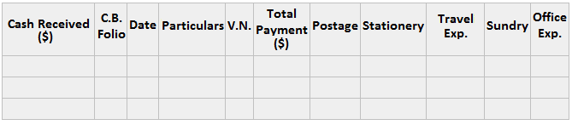
Imprest System of Petty Cash
Under the imprest system, total petty expenses for a specific period are estimated and the amount is advanced to the petty cashier. This amount is known as Imprest.
The petty cashier spends the imprest cash during the period. At the end of the period, the petty cashier submits the statements covering petty expenditures to the chief cashier. The amount spent by the petty cashier is refunded, thus making up the balance to the original amount.
In this way, the petty cashier will begin every period with an amount equal to imprest cash, and the amount held by the petty cashier will never exceed this.
Advantages of Imprest System
- Time savings for the chief cashier who is responsible for the main cash book.
- Reduction of the chance of cash misuse because the petty cashier is not allowed to keep idle cash.
- Reduction of the chance of misappropriation as the imprest cash is a small amount.
- Errors are corrected quickly because the chief cashier checks the petty cash record periodically.
- Creation of opportunities for junior staff to learn how to handle money responsibly.

