SS 1 COMPUTER STUDIES FIRST TERM
SCHEME OF WORK
TOPIC CONTENT
- Overview of the computer System Definition of computer, Characteristics
of computer, Main parts of a computer.
- Overview of the computer System Definition of computer hardware, parts
& examples of a computer hardware.
- Overview of the computer System definition of computer software, types &
examples of computer software.
- Data and Information Definition of data and Information,
examples and sources.
- Computing Device I Features, components & uses of Abacus,
(Pre-Computing age to 19th century) Napier bones, Slide rule.
- Computing Device I Features, components & uses of Jaquard
(Pre-Computing age to 19th century) loom, Analytical engine, Hollerith census
- Computing Device II Features, components & uses of ENIAC
(20th Century to Date) & EDVAC.
- Computing Device II Features, components & uses of UNIVAC
(20th Century to Date) & PC.
- INPUT Devices Definition & examples of Input Devices,
Uses & features of keyboard & mouse.
- INPUT Devices Features and uses of Scanner & Joystick.
- REVISION
- EXAMINATION.

1-3. OVERVIEW OF COMPUTER SYSTEM
SPECIFIC OBJECTIVES: At the end of this lesson, I should be able to;
- Define a computer.
- List the classification of a computer.
- Define & list the parts of the computer hardware.
- Define and list types of computer software.
- List the characteristics of a computer.
DEFINITION OF A COMPUTER.
A Computer is an electronic device that accepts data, process the data based on the particular instructions given to it into useable information and store this information for future use.
Three keywords are seen in the above definition of a computer and they are; Electronic device, Data, Information
- ELECTRONIC DEVICE: this is any machine or equipment that works with the aid of electronic parts, which is designed to serve a specific function. E.g., Computers, television sets, radios, mobile phones etc.
- DATA: This simply means any collection of facts and figures for analysis or reference. E.g., the number of students in a class, the ages of SS 1 students in JC Best Schools.
- INFORMATION: This is the data that has been arranged or organised to make it useful for other purposes. E.g., the number of SS 3 students (DATA) in JC BEST Schools can be used to determine the number of students that will sit for National Examination Council (NECO) or West African Senior School Certificate Examination (WASSCE).
CHARACTERISTICS OF A COMPUTER
The major characteristics of a computer include;
- Speed
- Accuracy
- Storage
- Versatility
- Automation
- Productivity
- Efficiency
- Reliability.
SPEED: Computers can process instructions at a very high speed. E.g. in pic seconds (10⁻¹² seconds). The speed of a computer can be made faster or slower.
ACCURACY: this is the ability of the computer to produce correct result as expected.
VERSATILITY: this means that the computer can be used and applied to a variety of work, field and professions and can carry out both complex and simple task.
AUTOMATION: means that a computer processes data on its own without human intervention.
PRODUCTIVITY: Means that the computer is capable of functioning at a very high rate of production without slowing down.
RELIABILITY: Means that the computer can be trusted to perform complex calculations that are very difficult to handle by humans.
CLASSIFICATION OF A COMPUTER.
A computer is classified into two main parts, which are;
- Computer Hardware
- Computer Software.
COMPUTER HARDWARE
This is the physical components or parts of the computer that we interacts with( see, touch, feel). E.g.,
- Keyboard
- Mouse
- Monitor or computer screen
- Computer case and it all parts i.e. Hard disk drive, motherboard, video card etc.
PARTS OF THE COMPUTER HARDWARE.
Computer hardware is made up of two parts, which are;
  - System Unit
  - Peripherals.
SYSTEM UNIT: This is an enclosure of a box-like case made up of metal or plastic that houses the main processing components of the computer such as memory, micro-processor, motherboard, internal disk drives, ports, central processing unit (C.P.U), power supply etc. that are used to process data and produce result (information). The system unit is called computer case, tower or chassis.
PERIPHERALS: Every other external or internal part of the computer connected to the system unit is called a PERIPHERAL. E.G., keyboard, mouse, monitor, printer, scanner, compact disc (CD) drives, hard drive, flash drive, speakers etc.
NOTE: These devices (PERIPHERAL) only help to expand the ability of the computer but do not contribute to the computing function of the system.
COMPUTER SOFTWARE
This is a set of instructions or programs that tells the computer what to do. It cannot be physically touched, but can be stored on a physical medium like CD-ROM. Examples include; computer games, Microsoft word, Ms excel, Music and video’s stored on computers.
TYPES OF COMPUTER SOFTWARE.
There are two main types of computer software, which are;
- System software
- Application software
SYSTEM SOFTWARE: This is a program that controls how the computer hard-ware works and provides a platform on which application software runs. It is essentially the main software that makes the computer useable without which the user cannot interact with the computer. The major function of the system software includes;
- It helps users to start and run the computer system and networks.
- It controls how the different hardware of the computer works together.
- It has to be present before any other application such as Microsoft word, excel, Access, games etc. can be installed.
The different types of system software include the following:
- OPERATING SYSTEM: These are the main items of the system software without which no computer will work. Examples are windows 98, XP, 7, 8.
- DEVICE DRIVERS: These are software that helps different devices or parts of the computer to work together with the system unit. Thus, they are usually provided by a hardware producer that instructs the system unit on exactly how to use it. There are device drivers for printers, displays, CD-ROM, audio signals etc.
- UTILITIES: these are software that helps to manage the computer.
- LANGUAGE TRANSLATORS: these are software that converts instructions given by the users to computers language.
APPLICATION SOFTWARE: these are programs installed on the system software that are designed to help users carry out specific applications or tasks such as word processing, accounting, graphic design, photo editing etc. or general applications or tasks such as word processing, web browsing etc. Examples includes; core draw, Photoshop, power point, Ms word, Ms excel, Ms access etc.

4. DATA AND INFORMATION
SPECIFIC OBJECTIVES: At the end of this lesson, I should be able to;
- Define data and information.
- Give examples of data and information.
- State the differences between data and information.

DEFINITION OF DATA
Data can be defined as the collection of raw or unprocessed facts that are given or fed into the computer as input for it to work on. These facts can be in form of numbers, words/text, measurements, symbols, observations etc. examples, the number of boys in SS 1d, the height of all the girls in SS 1c, ages, names, weights can be said to be data.
CLASSIFICATION OF DATA
Data can be classified as either quantitative or qualitative.
QUANTITATIVE DATA: This is measurement expressed in terms of numbers of numerical figures, which makes it countable. E.g., questions such as age, class, length, weight, etc. we can present such data in graphical formats, charts etc. Quantitative data is also classified into; discrete data and continuous data.
QUALITATIVE DATA: This is when data presented has words and descriptions. These type of data are sorted by category and can’t be measured or counted. E.g., describing taste, experience, texture, images. This data is collected through focus groups, personal interviews, surveys, open-ended questions etc. qualitative data is classified into nominal data and ordinal data.
ASSIGNMENT: WRITE SHORT NOTE ON NOMINAL AND ORDINAL DATA, DISCRETE AND CONTINUOUS DATA AND GIVE EXAMPLES OF EACH.
SOURCES OF DATA
The source of data is where it can be obtained or collected. It is divided into two main types: primary data & secondary data.
PRIMARY DATA: This is data which is raw, original and extracted directly from the official sources. This type of data is collected using questionnaires, interviews and surveys.
SECONDARY DATA: this is data which has already been collected and reused again for some valid purpose. It is previously recorded in the primary data and has two types of sources named internal source and external source.
DEFINITION OF INFORMATION
Information is data that has been re-arranged, organised, analyzed, processed and interpreted by the computer to give a meaning(OUTPUT). It is also processed data on which decisions and actions are based. E.g., Charles Darwin’s theory of evolution, driving a car, tying a shoelace, genetics and DNA, theory of gravity, coaching etc.
CLASSIFICATION OF INFORMATION
Information can be classified based on the forms in which it can exist, the time of occurrence and the frequency of occurrence.
CLASSIFICATION OF INFORMATION BASED ON FORM.
WRITTEN INFORMATION: this includes information made up of numbers and words.
ORAL INFORMATION: this refers to verbal communication between two or more people.
VISUAL INFORMATION: this refers to information communicated graphically, pictorially or by means of some representation.
SENSORY INFORMATION: this refers to information communicated or perceived by the five senses of hearing, smelling, seeing, feeling and touching.
CLASSIFICATION OF INFORMATION BY TIME
HISTORICAL INFORMATION: this refers to events, activities and transaction which happened in the past. This type of information is actually data i.e. data of birth but can however be processed to yield information.
PRESENT INFORMATION: this refers to information on current issues and day-to-day activities and transactions.
FUTURE INFORMATION: this refers to predictions and projections about activities and events likely to take place in the future.
CLASSIFICATION OF INFORMATION BY FREQUENCY OF USE
Information may be communicated continuously as in radio and television broadcast by seconds, minutes, hourly, daily, monthly, annually.
SOURCES OF INFORMATION
There are various sources of information typically classified as primary, secondary and tertiary.
PRIMARY INFORMATION SOURCES: this provides direct or firsthand information about event, person, object, or work of art. They are original materials which have not been interpreted, condensed, or evaluated by a second party. E.g., diaries, poems, speeches, paintings, interviews, experiments etc.
SECONDARY INFORMATION SOURCES: this source analyzes, interprets, or discusses information about a primary information source. They are subsequent to what they describe, as they are produced at some point after primary source appears. E.g., textbooks, biographies, book reviews, histories, magazine articles etc.
TERTIARY INFORMATION SOURCES: this source lists, complies, or indexes primary and secondary information sources. These resources are most often used to look up facts or to get a general idea about something. E.g., manuals, indexes, handbooks, guidebooks, statistics, almanacs etc.
NOTE: Information should possess features that can assist the holder to make good and appropriate decision. Wrong information can mislead people into making poor decisions & choices.
CHARACTERISTICS OF GOOD INFORMATION
- RELEVANCE: the information collected should be related to the project at hand and help in decision making.
- CURRENTNESS: the information should be current/recent so as to help solve immediate problems.
- ACCURACY: the information must be extremely accurate streaming from an accurate data collection
- CORRECTNESS: the information should be free from errors.
- RELIABILITY: the information should come from a valid source of authority.

5-6. COMPUTING DEVICES I (PRE-COMPUTING AGE TO 19TH CENTURY)
SPECIFIC OBJECTIVE: At the of this lesson, I should be able to;
- Define Computing.
- List early computing devices and their inventors.
- List the uses, structure and year each device was developed.

DEFINITION OF COMPUTING.
Computing is a process of utilizing computer technology to complete a task. It can also be defined as the study of how computers work and how they are constructed and programmed.
EARLY COMPUTING DEVICES
- Slide rule
- Pascal’s calculator
- Abacus
- John von Neumann machine
- Analytical engine
- Leibnz calculator
- Schickards calculating clock
- Napier bones
- Herman Hollerith punch card.
SLIDE RULE.
USES: It is used mainly for multiplication and division, and also for scientific functions such as roots, logarithms and trigonometry.
STRUCTURE: It is a linear/circular shaped ruler like object having logarithmic scale.
INVENTOR: William Oughtred developed it in 1622.
PASCAL’S CALCULATOR
USES: it is used to perform addition, subtraction, multiplication and division.
STRUCTURE: it is made up of lantern gear and water wheels.
INVENTOR: Blaise Pascal a French Mathematician-philosopher designed & built PASCALINE in 1642.
ABACUS
USES: this is the first mechanical calculating device; it was used to perform addition and subtraction easily and speedily.
STRUCTURE: it is made up of wooden frame with rods fitted across with record beads sliding on the rod.
INVENTOR: Abacus was first developed by the Egyptians in the 10th century.
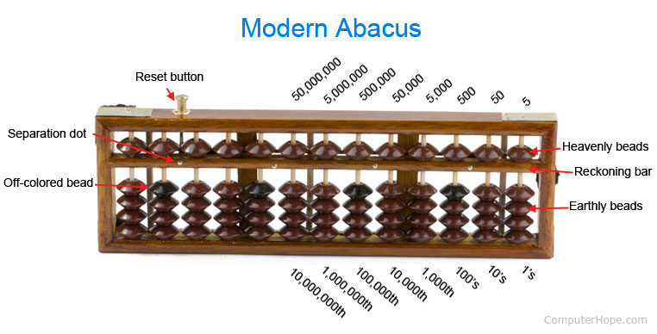
HERMAN HOLLERITH PUNCH CARD
USES: used to tabulate statistics from millions of pieces of data. It was used to process USA 1890 census data.
STRUCTURE: it is made up of punch cards.
INVENTOR: Herman Hollerith an American statistician developed it in 1889.
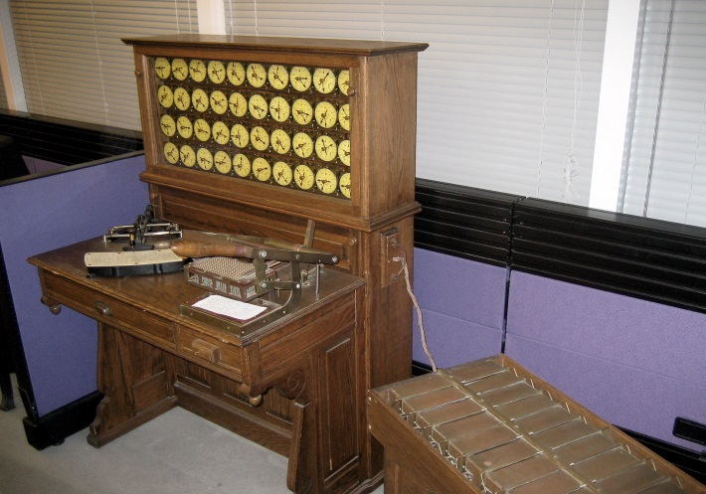
ANALYTICAL ENGINE
USES: it is used to calculate the numerical value of trigonometric functions of any formula.
STRUCTURE: it comprises of these components; mill, the store, the reader, and the printer.
INVENTOR: it was designed by Charles Babbage an English mathematician in 1833.
LEIBNIZ CALCULATOR
USES: it performs all four arithmetic operations; addition, subtraction, multiplication and division. It is also called STEP RECKONER.
STRUCTURE: it is made up of gears and wheels.
INVENTOR: Gottfried Leibniz a German mathematician developed it in 1671.
NAPIER BONES
USES: this computing device uses logarithm to perform multiplication through addition.
STRUCTURE: these are ivory sticks on which logarithm values were carved.
INVENTOR: Invented in 1617 by a Scotsman named John Napier who is also the original inventor of the logarithm printed on table (LOGARITHM TABLE).
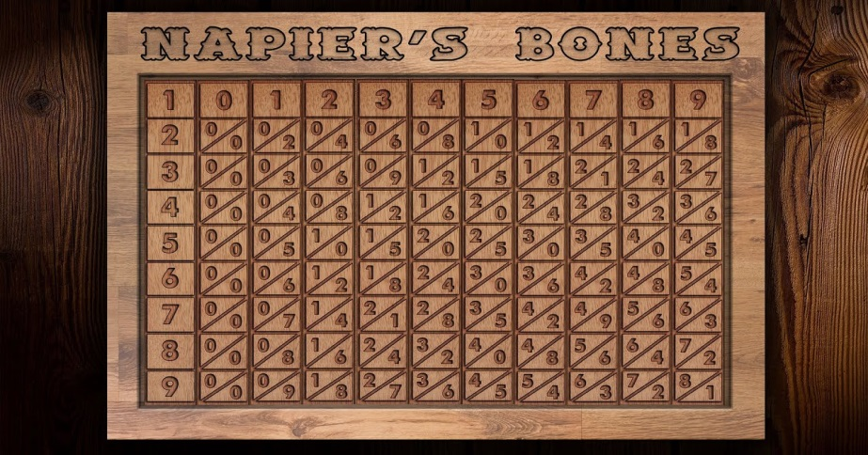
SCHICKARD’S CALCULATING CLOCK
USES: this is used for addition, subtraction, multiplication and division.
STRUCTURE: it is made up of gears and arrangement of rotatable Napier’s bones.
INVENTOR: Wilhelm Schickard a German professor of Hebrew & Astronomy developed it in 1623.
JACQUARD LOOM
USES: it is used to create complex design in textiles.
STRUCTURE: it is made up of punch cards and weaving treads.
INVENTOR: Joseph Mane Jasquard, a French Textile Manufacturer in 1801.
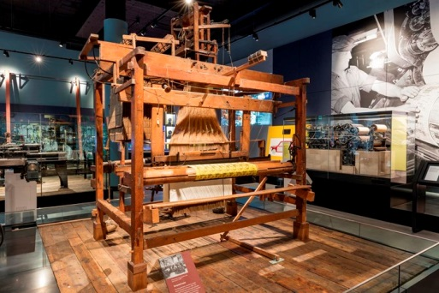
7-8 COMPUTING DEVICE II (20TH CENTURY TO DATE)
SPECIFIC OBJECTIVES: At the end of this lesson, I should be able to;
- State the various computing device (20th century to date)
- State the meaning of ENIAC, EDVAC, EDSAC, UNIVAC, and PC.
- State the inventor, year of production and how each works.
COMPUTING DEVICE 20TH CENTURY TO DATE
The 20th century to date computing devices are
- ENIAC
- EDVAC
- EDSAC
- UNIVAC
- PC.
ENIAC (ELECTRONIC NUMERICAL INTEGRATOR AND COMPUTER)
In 1946, John Mauchly and J. Presper Eckert completed the ENIAC. It was the first general purpose computer. ENIAC contained over 19,000 vacuum tubes, weighed 30tons, occupied 1,800 square feet of floor space and required 160 kilowatts of electrical power. The ENIAC used an IBM Card reader and punched card for its input and output respectively. ENIAC was used by USA for Hydrogen bomb project.
EDVAC (ELECTRONIC DISCRETE VARIABLE AUTOMATIC COMPUTER)
The EDVAC is the successor of the ENIAC and was made by the same designers (John Mauchly and J. Presper Eckert) in 1947. The EDVAC used binary rather than decimal input. It was the first computer designed stored program with memory capacity of 1,000 words (later set to 1024 words) thus giving memory in modern terms of 5.5kilobytes. It contained 6,000 vacuum tubes and consumed 56 kilowatts of electrical power and covered 490 square feet of floor space.
EDSAC (ELECTRONIC DELAY STORAGE AUTOMATIC COMPUTER)
This was an early British computer inspired by John Von Neumann’s seminal first draft of a report in the EDVAC. The machine was constructed by Maurice Wilkes in the year 1949 and his team at the University of Cambridge Mathematical Laboratory in England. It was a five hole punched tape as input and derated thermionic values as its CPU.
UNIVAC 1 (UNIVERSAL AUTOMATIC COMPUTER)
The UNIVAC 1 was inverted by John Mauchly and J. Presper Eckert in 1950. It was the first commercial programmable digital computer to be sold. The machine was 25 feet by 50 feet in length, contained 5,600 tubes, 18,000 crystal diodes and 300 relays and had an internal storage capacity of 1,000 words or 12,000 characters. It utilized a mercury delay line, magnetic tape for input & output, and typewriter output.
PERSONAL COMPUTER (PC)
The personal computer industry truly began in 1971 and these machines used eight-bit micro-processors (which mean they process information in groups of eight bits, or binary digits at a time) and possessed a limited memory capacity. Ted Hoff an intel engineer developed the first micro-processor a ¹/₁₆ by ¹/₈ inch chip called the 4004.
ASSIGNMENT: State the features and components of the following devices;
- Desktop Personal computers
- Laptop and Notebooks computers
- Palm top computers.

9-10. INPUT DEVICES
SPECIFIC OBJECTIVES: At the end of this lesson, I should be able to;
- Define Input devices.
- Identify and describe Input devices.
- State the uses of the various Input devices.

DEFINITION OF INPUT DEVICES
Input devices are computer hardware equipment used to provide data and control instructions or signals to computers and other information processing systems. Input devices convert raw data into the appropriate format or language that can be easily understood by a computer. Examples are; keyboard, mouse, joystick, touch pad, light pen, track ball, scanner, stylus, Microphone, digital camera, webcam, magnetic ink card reader (MICR), Bar code reader, optical Mark reader (OMR), QR Code reader etc.
JOYSTICK: Widely used to play games on a computer. They help control the characters and vehicles of the game. It can be a standalone device or can be included with multiple buttons and can move in all four directions.
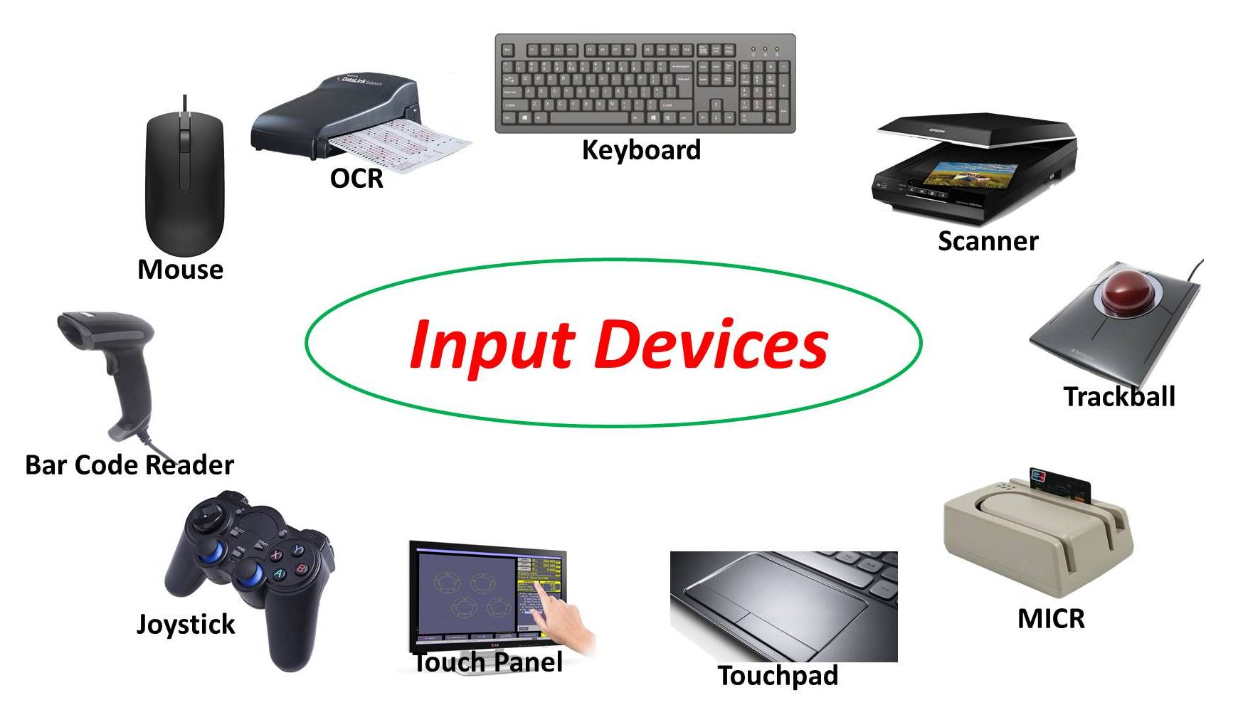
TOUCHPAD: also known as track pad, is an input device that is primarily integrated with a laptop.it is a common alternative to a mouse and helps to make computer devices compact, small & lightweight. It was introduced in 1990.
LIGHT PEN: this is a pointing device that has the same structure as a pen. It is a light sensitive device consisting of a photocell and an optical system placed in a small tube used mainly to select on-screen items, draw pictures and write independently in document files using a computer screen.
MICROPHONE: also known as a MIC, is a type of voice input device that allows users to send voice input into a computer system.
DIGITAL CAMERA: is an input device that is used to capture images and video in digital form. It uses an image sensor chip to capture images rather than the film used by traditional cameras of the old days.
WEBCAM: used to capture images and videos and convert them into digital form. A webcam cannot operate independently unlike the digital camera and don’t have inbuilt memory.
MAGNETIC INK CARD READER (MICR): this a device that typically reads characters or texts that are printed on paper using ink that contains particles of magnetic material. This device is mainly used in banks to read the CHEQUE NUMBER & BANK CODE and to send a signal to the computer to process a valid cheque. This process is known as Magnetic Ink character Recognition.
OPTICAL CHARACTER READER (OCR): this is an input device used to read the handwritten or printed text optically character by character and convert them into digital text to be stored in a computer.
BAR CODE READER: also barcode scanner is an input device used to read bar codes usually printed on various items for labeling details.
SCANNER: this is an essential input device that allows us to convert a hard copy document into a digital file. It uses optical technology that reads characters or pictures from a paper and transfers them to a computer drive for further manipulation. Scanners have different types; photo scanner, flatbed scanner, drum scanner, sheet-fed scanner etc.
MOUSE: this is the most common pointing device that helps interact with a computer through a process called ‘point and click’. This is mainly used to move a cursor on the computer’s screen and click on the corresponding object using its buttons (usually left, right, and middle key roller buttons). The left button helps select items while the right button helps display menus. Mouse come in various types; optical mouse, gaming mouse, wireless mouse, laser mouse, trackball mouse, mechanical mouse, 3D mouse, wired mouse etc.
KEYBOARDS: is a peripheral input device modeled after the typewriter which uses an arrangement of buttons or keys to act as mechanical levers or electronic switches. It is used to type instructions that direct the computer on what to do. They are two main types of keyboard; STANDARD AND ENHANCED keyboard.
LIST OF COMMON CONTROL KEY SHORTCUTS.
Ctrl + A: select all or other objects.
Ctrl + B: bold highlighted text
Ctrl + C: copy any selected text or object
Ctrl + D: bookmark an open web page or open font window in Ms word
Ctrl + E: center text
Ctrl + F: open find window
Ctrl + G: open find in a browser or word processor
Ctrl + H: open Find and replace in notepad, Ms word, wordPad
Ctrl + I: Italicize text
Ctrl + J: view downloads in browsers and set Justify Alignment in Ms word
Ctrl + K: create hyperlink for the highlighted text in Ms word
Ctrl + L: select address bar in browser or left align text in word processor
Ctrl + M: Indent selected text in word processor
Ctrl + N: create a new page or document
Ctrl + O: open a file in most programs
Ctrl + P: open a print window
Ctrl + R: reload page in browser or right align text in word processor
Ctrl + S: save documents or file
Ctrl + T: create new tab in browser or adjust tabs in word processor
Ctrl + U: underline selected text
Ctrl + V: paste any text that has been copied
Ctrl + W: close open tab or document
Ctrl + X: Cut selected text or object
Ctrl + Y: redo any action
Ctrl + Z: undo any action
Ctrl + End: moves cursor to the end of a document instead of end of the line
Ctrl + Esc: open the windows start menu.

